**Bouncing Ball**

1. Install Dev-C++

<https://sourceforge.net/projects/orwelldevcpp/>

1. Install WinBGIm Graphics Library in Dev C++

<https://www.youtube.com/watch?v=gibqiFtBARY>

1. Open the folder “Bouncing Ball”
2. Double click on the file “Bouncing Ball.cpp”
3. Click the button “Compile and run” or press F11.

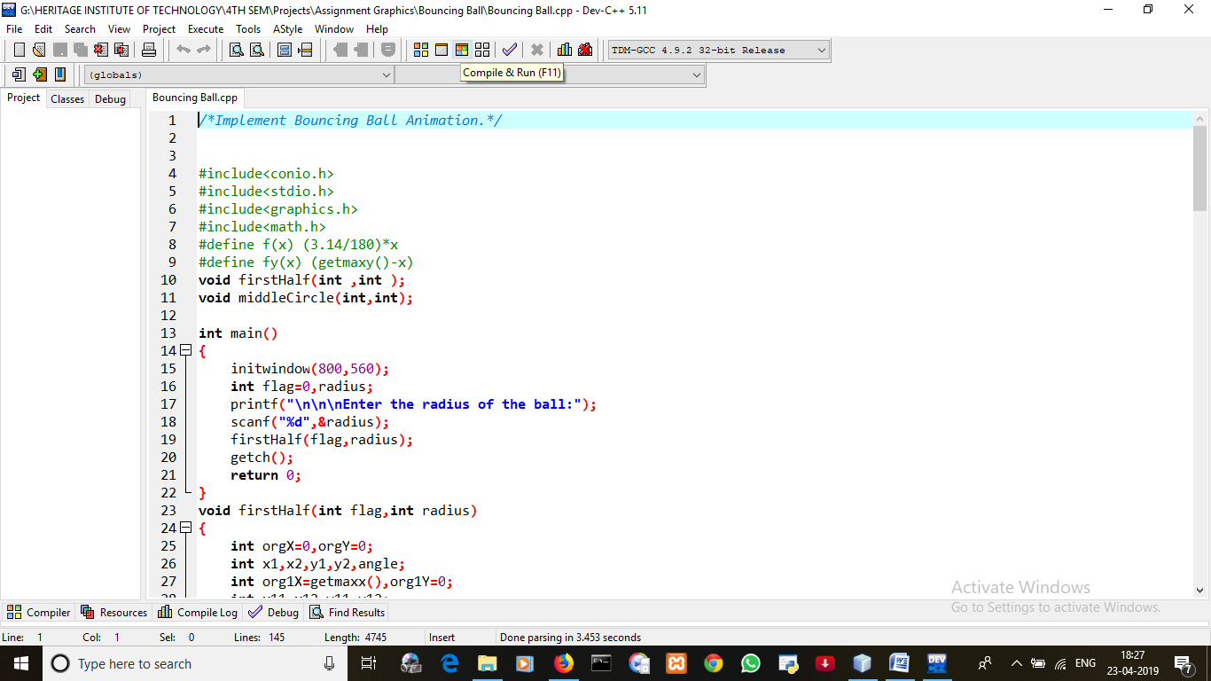

1. You will see something like this.

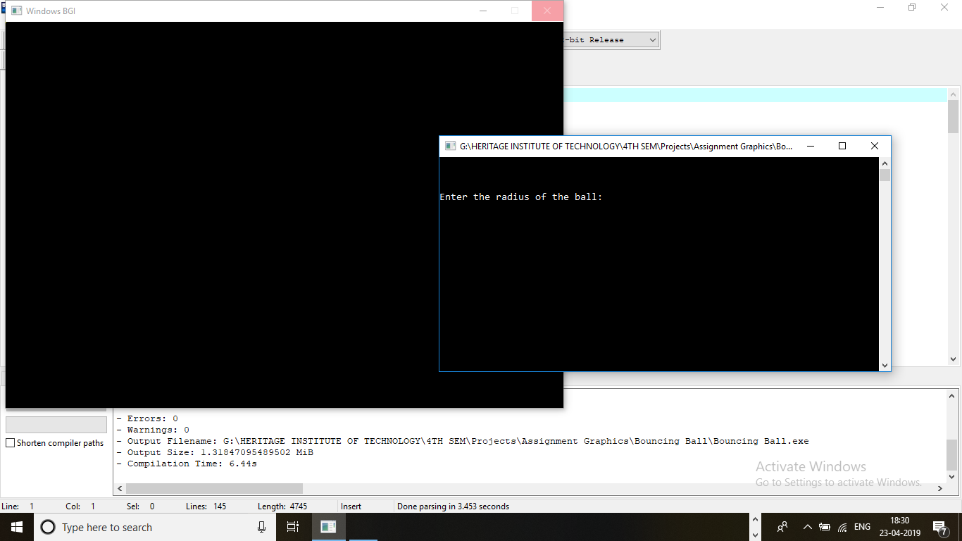

Enter the radius as you wish.

1. Let us enter the radius 40 here. ( as example)

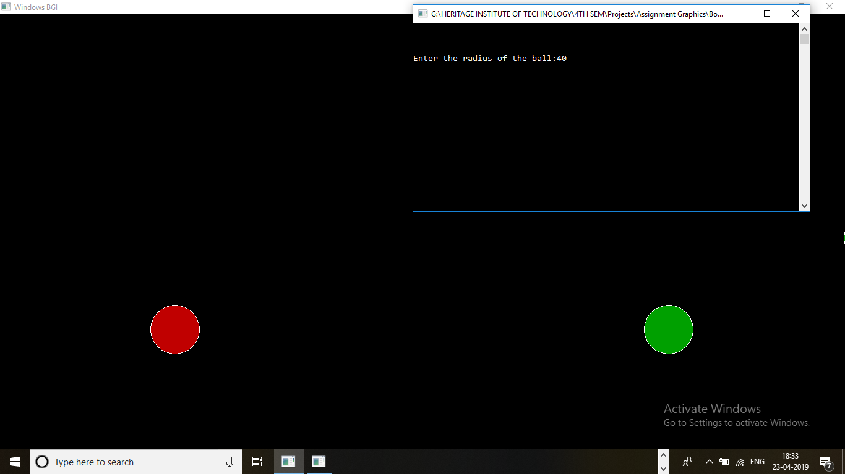



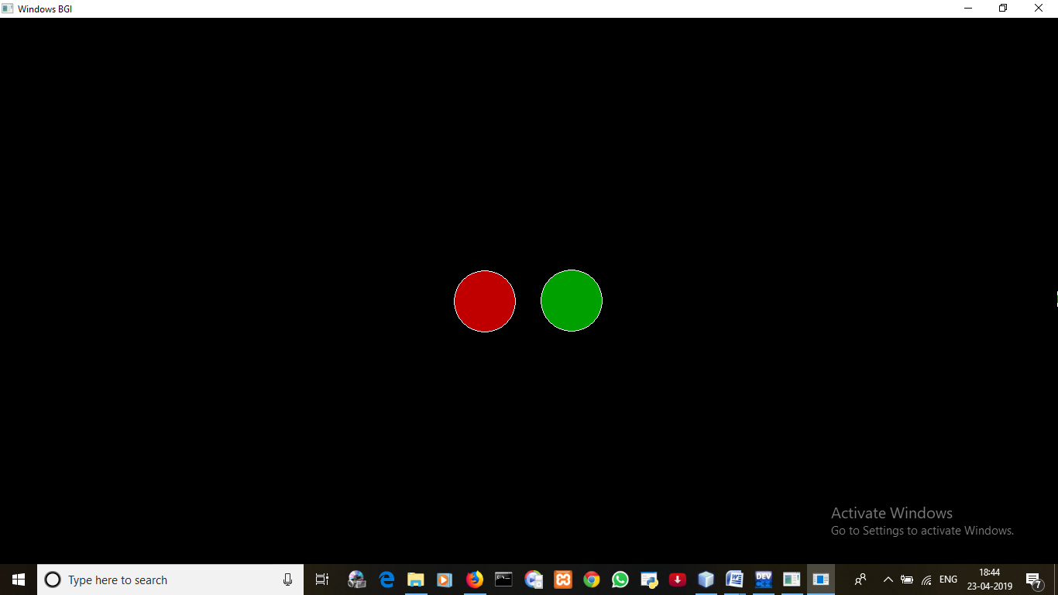

You will two balls bouncing in the output screen.

A .gif file named “Bouncing Ball (output).gif” has been included in the folder to show the animation of the two balls bouncing.

You are free to try with any radius.

**Note: Using Google Chrome or Mozilla Firefox is recommended.**